In-Flight Turbulence:

A Nonparametric Statistical Analysis of

Opinions on Acceptable Airplane Behavior

Faith Platz

Villanova University

Dr. Jesse Frey

MAT 8452

20 Dec 2018

In-Flight Turbulence: A Nonparametric Statistical Analysis of Opinions on

Acceptable Airplane Behavior

**INTRODUCTION**

According to the Federal Aviation Administration (FAA), more than 2.6 million people fly in and out of U.S. airports every single day (“Air Traffic,” 2018). While each flight is unique in its size, destination, flight duration, passengers, and many other factors, there seems to be a certain perception of how a passenger should act on his or her journey. After all, everyone in the aircraft’s manifest must coexist peacefully in a confined area that is seemingly detached from the rest of the world for the duration of the flight.

However, it is naïve to assume that everyone has the same ideas of what behavior is acceptable and what is not when traveling via airplane. This analysis aims to provide insight into the similarities and differences of opinion among Americans when it comes to this form of travel. The data that were used to perform this analysis came from FiveThirtyEight, a well-regarded website that presents analyses of many political, economic, sports-related, and other popular culture datasets. In August 2014, they administered a survey to their followers, asking for their opinions on airplane passenger behavior. There was not much documentation as to how the survey was exactly administered, so it may not be a truly random sample, but I will treat it as such over the course of this analysis. This led to the publishing of a story, “41 Percent Of Fliers Think You’re Rude If You Recline Your Seat,” written by then-chief culture writer Walt Hickey (2014). The article provided some descriptive analysis of the data collected but did not go much further than that.

The purpose of this project is to explore these data more deeply, utilizing nonparametric statistical methods to do so. Through the course of this analysis, new insights will be offered as to the types of indicators that influence perception, as well as attempting to identify the types of behavior that are even contentious in the first place.

**DATA WRANGLING & MANIPULATION**

The dataset that contained the survey responses is publicly available as a CSV file on FiveThirtyEight’s GitHub page. Upon reading the dataset into R, I added some variables as manipulations of preexisting values. First, since the “age” variable was not numeric and rather split into age range categories, I decided to further categorize these age ranges into generational categories, creating Millennial (18-29), Gen X (30-44) and Baby Boomer & Older (45+) categories. These do not perfectly match up with the traditional generational breakdowns, but it was as close as I could get to these categorizations with the ranges I was given.

All variables in the dataset were read in as categorical, but there were two particular variables I was able to convert to numeric in order to treat them as such in my later analyses. The first variable I converted was the respondent’s height, which was initially recorded as its height in feet and inches (e.g. 6’3”). I was able to convert this into a strictly numeric value by converting everything to inches. I did, however, have to make some small assumptions here. On the two extremes, the options available were “Under 5 ft.” and “6’6” and above.” In these cases, I made all responses in these categories 59in. and 78 in., respectively, since there was no way for me to know how far a respondent deviated from those values. Figure 1 shows the distribution of this numeric variable.

Figure 1: Distribution of Respondents’ Heights

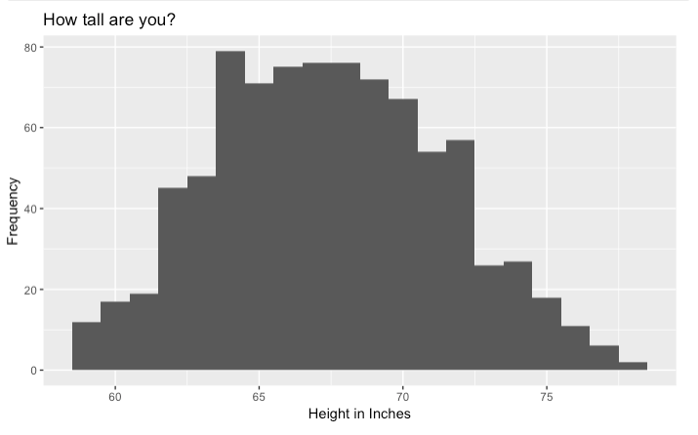

The other numeric variable I was able to produce came from the question that asked, “On a 6 hour flight from NYC to LA, how many times is it acceptable to get up if you're not in an aisle seat?” The response options included “It is not okay to get up during flight,” “Once,” “Twice,” “Three times,” “Four times,” and “More than five times.” I treated these as values from zero to five, respectively. Again, there was no way for me to know how many more times a person was envisioning on the upper end, so I made all values in the highest category equal five. Figure 2 demonstrates the distribution of responses to this question.

Figure 2: Distribution of Acceptable Times to Get Up

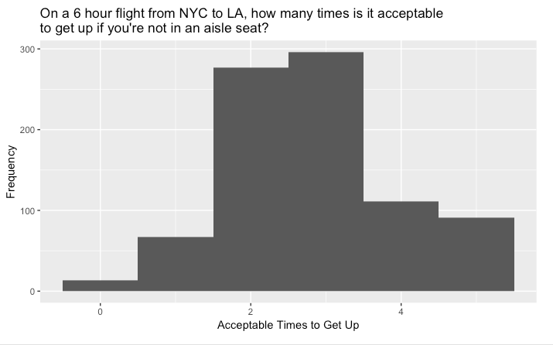

All other data manipulation performed before my analysis consisted of ensuring that ordered categories would be implemented correctly when running any ordered tests. This entailed renaming some categories and formatting variables as factors.

**HEIGHT ANALYSIS**

The first of the nonparametric methods I implemented with this dataset dealt with the now-numeric height variable. I wanted to run a test to see if my data matched up with national averages. To do this, I found a report issued from the Center for Disease Control (CDC) and the National Center for Health Statistics that included many tables for different height percentiles for American males and females over the age of 20 (Fryar, 2016). Since my dataset included only those 18 years or older, this measure should line up fairly well with my data if my data are indeed representative of the American population. The report found that the 50th percentile heights for females and males in the U.S. are 63.7 inches and 69.1 inches, respectively. Using the Sign Test, I was able to put these values up against my 50th percentiles for female and male heights of the survey respondents. This test assumes that the data are continuous and come from a random sample. Because of how the data were inputted, the height variable is not completely continuous, but I will treat it as such. As previously mentioned, I am treating these values as a random sample. The hypotheses were:

$H_{0}: θ_{0.5}=63.7 inches$ $H_{0}: θ_{0.5}=69.1 inches$

$H_{A}: θ_{0.5}≠63.7 inches$ $H_{A}: θ_{0.5}≠69.1 inches$

For both genders, the two-sided Sign Test showed a significant result, meaning that the 50th percentile of male and female heights in my dataset significantly differed from the national statistics, at the 5% level. In both cases, the survey respondents had a taller median height than CDC estimates. Table 1 shows more information about these tests. I also ran the parametric one-sample t-test and saw a similarly strong rejection of equality when comparing these CDC values with my sample means. That tested these hypotheses:

$H_{0}: μ=63.7 inches$ $H_{0}: μ=69.1 inches$

$H_{A}: μ≠63.7 inches$ $H_{A}: μ≠69.1 inches$

Both the parametric and nonparametric methods may be acceptable here, since height is typically fairly normally distributed. Figure 3 below shows the mound-shaped distributions of both male and female heights in my dataset.

I also used a two-sample nonparametric technique to compare heights between the genders in my dataset. Before running any tests, I must assume that the two samples of interest (males and females) are independent and of equal shape. The genders are inherently independent, and Figure 3 shows the two distributions side by side, demonstrating that the sizes are roughly similar, so I will proceed.

Figure 3: Distribution of Height by Gender

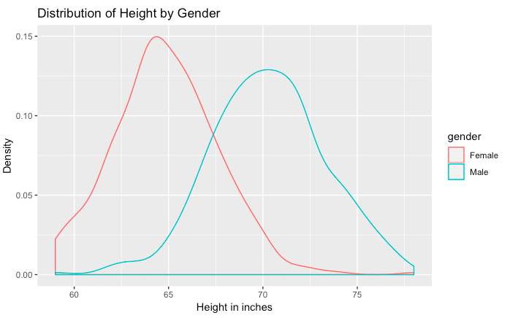

Using the two-sided Wilcoxon Rank Sum Test, I found that male and female heights significantly differed (Table 2), utilizing the following hypotheses:

$$H_{0}: ∆ =0$$

$$H_{A}:∆ ≠0$$

Upon investigating the 95% confidence interval for the difference, I am 95% confident that males tend to be between five and six inches taller than females. When comparing this result to the parametric two-sample t-test, the same result is achieved, using the same hypotheses as the Wilcoxon Rank Sum Test. To fully rely on the t-test, however, I would have to make sure each gender’s heights are in fact normally distributed, which may or may not be met due to the abnormal tails.

**RECLINING SEATS AND HEIGHT**

Since my data analysis was focused on airplane behavior, I wanted to examine this height variable against several questions that addressed respondents’ opinions. I hypothesized that people of different heights may have different opinions about the reclining seats on an airplane due to limited leg room, so I narrowed my height analysis to the four questions that dealt with this. The four questions are listed below.

1. “Do you ever recline your seat when you fly?”
2. “Under normal circumstances, does a person who reclines their seat during a flight have any obligation to the person sitting behind them?”
3. “Is it rude to recline your seat on a plane?”
4. “Given the opportunity, would you eliminate the possibility of reclining seats on planes entirely?”

To test for height differences among responses to these questions, I ran more Wilcoxon Rank Sum Tests. To verify assumptions, a respondent can only choose one response to each question, making the samples independent, and each subset showed a fairly similar shape of its distribution. All distributions can be seen in Figures 5-8 in the Appendix.

When looking at the results (Table 3), there is only one question that resulted in significance, which was the question regarding eliminating the ability for seats to recline. This tells us that those who said they would eliminate reclining seats if given the opportunity were significantly taller than those who said they would not. This could suggest that reclining seats are more bothersome to people who are taller. However, I do not see a height difference among the other questions regarding reclining seats, which suggests that frequency, sense of obligation and perceived rudeness do not demonstrate substantial height differences.

**RUDENESS ANALYSIS**

There were nine questions in this survey that dealt with the rudeness of a certain action, each following the format of “Is it rude to…” accompanied by the response options “No, not rude at all,” “Yes, somewhat rude,” and “Yes, very rude.” Using each of these nine questions, I wanted to compare those results with the responses of the numeric variable “On a 6 hour flight from NYC to LA, how many times is it acceptable to get up if you're not in an aisle seat?” Since there were three ordered levels of perceived rudeness, I decided to run the Jonckheere-Terpstra (J-T) Test to see if increasing perceptions of rudeness led to a decrease in the amount of times someone thought it was acceptable to get up from a non-aisle seat. In all cases, the hypotheses were as follows:

$H_{0}: μ_{1}=$ $μ_{2}$ = $μ_{3}$

$H_{A}:μ_{1}≥μ_{2}\text{≥ }μ_{3}$ (w/ at least one strict inequality)

Table 4 summarizes the results of the nine tests, all of which are significant at the 5% level. This confirms my suspicions that as someone views one action as ruder, they tend to view fewer and fewer times a non-aisle passenger can get up as acceptable. Also included in the table are the p-values for the ANOVA F-test, a parametric alternative to the J-T test. This test has the same null hypothesis as the J-T Test, but with a two-sided, unordered alternative. However, it is uncertain if each group follow a normal distribution with equal variances, and the ANOVA F-test does not use an ordered alternative hypothesis like the J-T test. So, the J-T test is likely the better test to use in this case.

**MORE JONCKHEERE-TERPSTRA TESTS**

Since so many of the survey responses followed a very ordered structure, Jonckheere-Terpstra Tests made a lot of sense to use for analysis. Continuing with my analysis of acceptable times for a non-aisle sitter to get up, I looked at several other ordered variables, this time using the increasing alternative hypothesis:

$H_{0}: μ_{1}=$ $μ_{2}$ = $μ_{3}$

$H_{A}:μ_{1}≤μ_{2}\text{≤ }μ_{3}$ (w/ at least one strict inequality)

The only significant result seen here (Table 5) deals with recline frequency, suggesting that as someone reclines their seat more often, they tend to view more and more times a non-aisle passenger can get up as acceptable. This result somewhat coincides with the earlier finding that as someone thought it was ruder to recline one’s seat, their idea of how many times one could get up decreased. Again, the ANOVA F-test results are also shown in Table 5, but likely are less reliable than the J-T results due to the ordered nature of the response options.

**COMPARING GENERATIONS**

Since there were so many categorical variables in this dataset, I naturally wanted to test for association between these variables. I decided to focus on comparing several survey questions with the respondent’s generation, to see if there are any generational differences in opinions on airplane behavior. This sort of analysis lends itself well to Chi-Square Tests for Independence, which is a parametric method for comparing categorical variables. The hypotheses all follow this general framework:

$H_{0}:$ Generation is not associated with

$H_{A}:$ ________

Generation is associated with ________

However, sometimes the minimum expected count requirements are not met, so a nonparametric method must be implemented. For this analysis, I ran the nonparametric Permutation Chi-Square test and the parametric Chi-Square Test for Independence in each case. The results can be seen in Table 6. For two of the variables of interest, “In a row of three seats, who should get to use the two arm rests?” and “Have you ever smoked a cigarette in an airplane bathroom when it was against the rules?” did not meet the minimum expected count threshold, so the permutation version of the test is preferred. In each case though, the parametric and nonparametric tests come to the same conclusions at the 5% level.

These results demonstrate some generational differences. The full frequency tables for the three significant results can be seen in Tables 7-9. First, it appears that the difference in opinion about who has control of the window shade belongs to Generation X. Based on my data, the majority (52.3%) of Gen X’ers believe the window shade’s control is completely in the hands of the person sitting in the window seat, whereas over 60% of Baby Boomers and Millennials alike take a more egalitarian approach, opting for shared control.

When assessing ownership of the middle armrest in a row of two seats, there seems to be an incremental change as generations become younger. The older generations had higher proportions of wanting to share the armrest, decreasing with the younger generations. Consequently, proportions of assigning ownership to either the person in the aisle seat or whoever claims the armrest first tend to increase as generations become younger. This could point to a general trend of a less communal environment on airplanes with the emergence of the Millennial generation.

The other significant generational difference observed here deals with violating the rules by using personal electronics during take-off or landing. The Baby Boomer generation shows a much lower proportion of respondents who admitted to violating these rules than Gen X or the Millennials. Millennials showed the highest proportion of violators (29.7%), suggesting that the emerging generations may have very different opinions about the validity of these rule and how they should be followed, if at all.

**COMPARING VIOLATION RATES**

Because there were only two questions that dealt specifically with violating the rules of an aircraft, each with simple Yes/No response options, I wanted to compare them and see if they differed in their violation rates. In other words, I was interested in seeing whether people admitted to one violation more often than the other. To accomplish this, I ran McNemar’s Test. This test addresses exactly this question, focusing solely on the disagreements between the two questions. The hypotheses are as follows:

$$H_{0}:π_{1}=π_{2}$$

$$H_{A}:π_{1}≠π_{2}$$

Since each respondent answered both questions, I can look to see the occurrences where a respondent answered “Yes” to one question and “No” to the other. Table 10 shows the breakdown of answers for these two questions. Of the 849 people who answered both questions, there were 131 disagreements, which is very far from half, yielding a very small p-value as a result. This tells me that these two violations have different rates of occurrence. When looking back at the frequency tables, about 16% of respondents said they had used personal electronics during take-off or landing, but less than 1% said the same about smoking a cigarette in an airplane bathroom. This may be partially explained by the fact that only a subset of the population smokes cigarettes at all, while a much larger subset has access to personal electronics. Still, there is one violation that clearly occurs more often than the other.

**LINEAR ASSOCIATION**

With the two numeric variables I used throughout this analysis, I wanted to see if they had any sort of association with each other. To accomplish this, I initially plotted the values as ordered pairs (Figure 4), leading me to be skeptical of any strong linear dependencies between height and number of acceptable times a non-aisle passenger may get up.

Figure 4: Acceptable Times to Get Up vs. Height

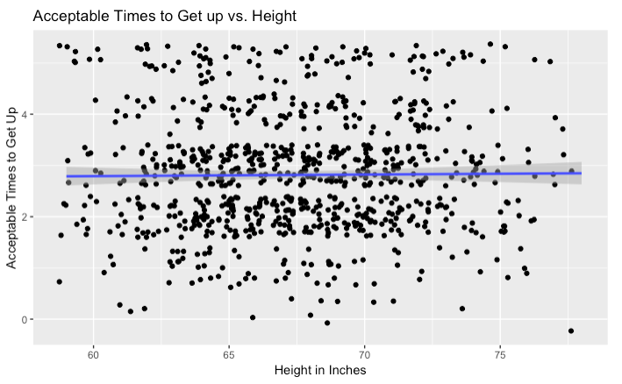

Even still, I ran permutation versions of both parametric and nonparametric methods to assess linear dependency, due to the large number of ties in the data. The hypotheses for both tests are:

$$H_{0}: ρ=0$$

$$H_{A}:ρ≠0$$

Both Spearman’s and Pearson’s correlation permutation tests resulted in insignificance, as evidenced in Table 11. This is not surprising based on the scatterplot.

Just to check for *any* type of dependency between height and the number of acceptable times a non-aisle sitter may get up, I also ran Hoeffding’s Test, which detects any type of dependency, linear or otherwise. Its hypotheses are:

$$H_{0}: ∆ =0$$

$$H_{A}: ∆ ≠0$$

Even still, there was no evidence of a relationship.

**CONCLUSIONS**

In summary, there appeared to be several findings that could provide useful insight into the perception of appropriate airplane behavior. First, there is a sizeable number of people who would like to see the ability for seats to recline disappear. About 30% of people who answered this yes/no question said “Yes,” they would like to see it eliminated. Furthermore, the people who said this tended to be taller than those who answered “No.” Perhaps the reclining ability is more of a hindrance than a luxury for the taller airplane passenger.

Also evident from this analysis is the relationship between perceptions of rude behavior and the number of times one thinks it is acceptable for a non-aisle passenger to get out of his or her seat during a six-hour flight. Across all questions assessing rudeness, as an action was thought of as ruder, the number of acceptable times to get up decreased. This may suggest that, for those who view other behavior as rude, they view getting up out of a non-aisle seat to be rude as well. This measure of the number of acceptable times to get up, however, had no significant association with a passenger’s height.

There were some striking outcomes when assessing generational differences in responses to the more territorial and rule-breaking questions. Older generations aired toward a more egalitarian approach to the control of the window shade and the middle armrest, whereas younger generations showed a stronger tendency to allocate control to a certain person. This is especially the case when it comes to use of the middle armrest. Perhaps this gives some insight into why older generations may be displeased with their younger and potentially more uptight counterparts.

Using the nonparametric techniques I’ve learned in this course, I was able to provide a fuller analysis of this airplane behavior survey data than the original FiveThirtyEight article. There certainly remains much more analysis that can be conducted with these data, but the point remains; there is so much more to a dataset than its basic descriptive statistics and average values. Virtually any collection of data can lead to actionable and meaningful analysis, but sometimes the analyst has to get a bit creative with its implementation. Thanks to nonparametric statistics, tests that used to be limited by strict normality and other guidelines can be administered to a much broader set of data.

The millions of passengers who traverse the skies every single day will always have differing ideas about what the ideal travel behavior looks like. However, through these methods of statistical analysis, I have realized that there are many factors that can shape these perceptions. If we can continue to be aware of what the people around us view as unacceptable, we can adapt our own behavior, making for a smoother, less turbulent flight – at least from a social perspective.

Appendix A: Tables

Table 1a: Sign Test for Height

|  |  |  |  |  |
| --- | --- | --- | --- | --- |
|  | CDC Estimate | Test Statistic B | Total | p-value |
| Female | 63.7 in. | 310 | 528 | < 0.0001 |
| Male | 69.1 in. | 240 | 479 | < 0.0001 |

Table 1b: One-Sample t-Test for Height

|  |  |  |  |
| --- | --- | --- | --- |
|  | CDC Estimate | Test Statistic t | p-value |
| Female | 63.7 in. | 8.65 | < 0.0001 |
| Male | 69.1 in. | 7.81 | < 0.0001 |

Table 2a: Wilcoxon Rank Sum Test for Height by Gender

|  |  |  |  |
| --- | --- | --- | --- |
|  | Test Statistic W | 95% CI for Diff. | p-value |
| Male - Female | 161060 | (5.00, 6.00) | < 0.0001 |

Table 2b: Two-Sample t-Test for Height by Gender

|  |  |  |  |
| --- | --- | --- | --- |
|  | Test Statistic t | 95% CI for Diff. | p-value |
| Male - Female | 27.09 | (5.03, 5.82) | < 0.0001 |

Table 3a: Wilcoxon Rank Sum Test for Height by Reclining Opinions

|  |  |  |  |
| --- | --- | --- | --- |
|  | Test Statistic W | 95% CI for Diff. | p-value |
| Recline Frequency (“Always” vs. “Never”) | 11210 | (-1.00, 1.00) | 0.5165 |
| Recline Obligation | 83309 | (-1.00, 0.0004) | 0.7446 |
| Rude: Recline | 89507 | (-0.00005, 1.00) | 0.7442 |
| Eliminate Recline | 84464 | (0.000003, 1.00) | 0.0249 |

Table 3b: Two-Sample t-test for Height by Reclining Opinions

|  |  |  |  |
| --- | --- | --- | --- |
|  | Test Statistic t | 95% CI for Diff. | p-value |
| Recline Frequency (“Always” vs. “Never”) | -0.64 | (-1.22, 0.62) | 0.5215 |
| Recline Obligation | -0.24 | (-0.62, 0.49) | 0.8162 |
| Rude: Recline | 0.64 | (-0.37, 0.73) | 0.5210 |
| Eliminate Recline | 2.36 | (0.12, 1.31) | 0.0187 |

Table 4: Jonckheere-Terpstra and One-Way ANOVA Tests for Acceptable Times a Non-Aisle Passenger can get up

|  |  |  |  |  |
| --- | --- | --- | --- | --- |
| Rude? | Test Statistic JT (decreasing) | p-value | Test Stat. F | p-value |
| Speak to Stranger | 53464 | 0.0015 | 10.28 | < 0.0001 |
| Wake Passenger to go to Bathroom | 68242 | 0.0005 | 23.93 | < 0.0001 |
| Wake Passenger to Walk Around | 79911 | 0.0005 | 36.33 | < 0.0001 |
| Bring Baby Aboard | 76801 | 0.029 | 3.73 | 0.0244 |
| Bring Unruly Children Aboard | 103570 | 0.0045 | 6.19 | 0.0021 |
| Recline Seat | 86506 | 0.001 | 9.13 | 0.0001 |
| Move to Unsold Seat | 49870 | 0.0005 | 7.70 | 0.0005 |
| Switch Seats to sit with Friends | 61852 | 0.0005 | 7.55 | 0.0006 |
| Switch Seats to sit with Family | 42934 | 0.001 | 9.52 | < 0.0001 |

Table 5: Jonckheere-Terpstra and One-Way ANOVA Tests for Acceptable Times a Non-Aisle Passenger can get up

|  |  |  |  |  |
| --- | --- | --- | --- | --- |
|  | Test Statistic JT (increasing) | p-value | Test Stat. F | p-value |
| Recline Freq. | 153560 | 0.0045 | 2.28 | 0.0589 |
| Travel Freq. | 75547 | 0.574 | 1.48 | 0.206 |
| Education Level | 129190 | 0.094 | 1.20 | 0.308 |
| Household Income | 92905 | 0.386 | 0.13 | 0.972 |
| Generation | 105320 | 0.7535 | 0.18 | 0.835 |

Table 6: Permutation Chi-Square and Chi-Square Test for Independence based on Generation

|  |  |  |  |
| --- | --- | --- | --- |
|  | Test Statistic $χ^{2}$ | Permutation  p-value | Parametric  p-value |
| Rude: Speak to Stranger | 1.5685 | 0.8286 | 0.8144 |
| Window Shade Control | 13.396 | 0.002 | 0.0012 |
| Middle Armrest (2 seats) | 31.166 | 0.0005 | 0.0001 |
| Middle Armrests  (3 seats) | 15.431 | 0.0515 | 0.0513 |
| Used Electronics Takeoff/Landing | 25.485 | 0.0005 | < 0.0001 |
| Smoked in Bathroom | 1.0047 | 0.5992 | 0.6051 |

Table 7: Who should have control of the window shade? 

Table 8: In a row of two seats, who should get to use the middle arm rest?



Table 9: Have you ever used personal electronics during take-off or landing in violation of a flight attendant’s direction?



Table 10: Frequency Breakdown of Rule Violations

|  |  |  |  |
| --- | --- | --- | --- |
| Have you ever smoked a cigarette in an airplane bathroom? |  | Have you ever used personal electronics during takeoff or landing? | |
|  | No | Yes |
| No | 712 | 130 |
| Yes | 1 | 6 |

Table 11: Tests for Association between height and number of acceptable times a non-aisle passenger can get up

|  |  |
| --- | --- |
| Test | p-value |
| Spearman’s Rho (permutation) | 0.4342 |
| Pearson’s (permutation) | 0.7511 |
| Hoeffding’s | 0.9263 |

Appendix B: Additional Figures

Figure 5: Distribution of Height by Recline Frequency



Figure 6: Distribution of Height by Opinion on Reclining Obligations



Figure 7: Distribution of Height by Rudeness of Reclining Seats



Figure 8: Distribution of Height by Support of Eliminating Reclining Seats

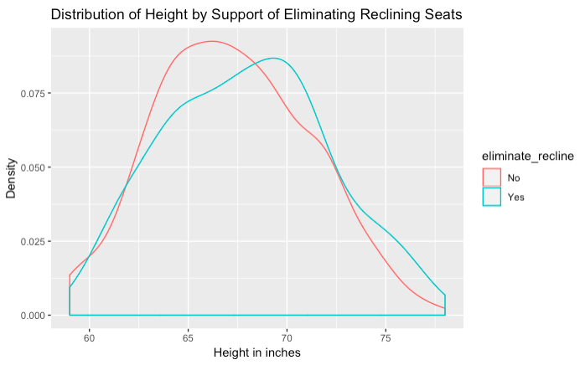

References

Air Traffic by the Numbers. (2018, November 26). In *Federal Aviation Administration*. Retrieved December 10, 2018.

Fryar, C., Gu, Q., Ogden, C., & Flegal, K. (2016, August). Anthropometric reference data for children and adults: United States, 2011–2014. National Center for Health Statistics. *Vital and Health Statistics*, 3(39).

Hickey, W. (2014, September 6). 41 Percent Of Fliers Think You’re Rude If You Recline Your Seat. In *FiveThirtyEight*. Retrieved December 10, 2018.